Contact Kate Brown  Telephone 202-213-7051  Email BUZZBYBROWN@GMAIL.COM | FOR IMMEDIATE RELEASE  September 8, 2014

CHRIS GATES CHOSEN AS Sunlight foundation’s new president

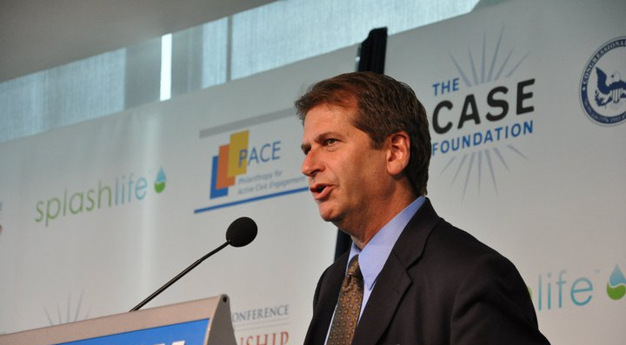
Washington, DC, September 8, 2014– The Sunlight Foundation, one of the foremost leaders in the use of technology to enable more complete, equitable and effective democratic participation, is pleased to announce that Chris Gates has been named as the organization’s new president.
Gates is a thought leader in the fields of democratic theory and practice and political and civic engagement. For the past three decades he has been a leading voice for strengthening democratic processes and structures and developing new approaches to both engagement and decision-making. Gates has been mentored by innovative leaders like John Gardner, Henry Cisneros, and Bill Bradley, and shares their goal of building a nation of engaged, informed and empowered citizens. He has extensive cross-sector experience, having been engaged in the private sector, the public sector, the non-profit sector, the world of politics and the field of philanthropy.
“I couldn’t be more excited to join the team at Sunlight to help advance their work to bring more accountability and transparency to our politics and our government,” said Gates. “For those of us who care deeply about the health of our democracy, these are perilous times. Our political system is swimming in anonymous money and influence, and our federal government is paralyzed and unable to respond to the challenges of our times. Our hope is that the new tools, data and information generated by Sunlight will help break through this impasse. We look forward to working with others in the reform field to fix a system that clearly isn’t working.”
Gates currently serves as the executive director of Philanthropy for Active Civic Engagement (PACE), an affinity group of the Council on Foundations and a learning collaborative of funders working in the civic engagement space. PACE works with philanthropic and non-profit organizations whose goal is to strengthen and invigorate America’s democratic practice, with a particular emphasis on the role that technology, information and social media play in empowering citizens to become more engaged. Gates also speaks and teaches extensively around the country on the topics of civic engagement and democratic theory, history and practice.
Prior to his time at PACE, Gates served for eleven years as president of the National Civic League (NCL), America's oldest good government organization, founded in 1894 by Theodore Roosevelt, and during that time also served as the co-director of the United States Healthy Communities Initiative and was co-director of John Gardner's Alliance for National Renewal. A graduate of Harvard’s Kennedy School of Government and the University of Colorado, Gates is an elected fellow of the National Academy of Public Administration (NAPA) and serves on the board of Public Agenda. He is a member of the editorial board of Public Administration Review (PAR), and a member of the board of advisors of the National Conference on Citizenship (NCoC). Gates previously served on the board of Independent Sector and was the co-chair of Robert Putnam's Saguaro Seminar at Harvard University.
Michael Klein, co-founder of Sunlight and chairman of the foundation’s board of directors said,
“We are thrilled to bring Gates' seasoned leadership skills to our organization. The board undertook an extensive national search for our new leader and we could not be happier to bring Chris Gates on as our new president. Ellen Miller has done an amazing job leading this organization through its first eight years and we have great faith that Chris will build on that success.”
Miller, Sunlight’s other co-founder and the organization’s first executive director, expressed her enthusiasm for the board’s selection:
“Chris brings to Sunlight a breadth of experience and style of leadership that will take this organization to new levels. Sunlight occupies a special place in the democracy reform movement and Chris is the perfect person to lead the organization through its next chapter.”
Miller, who previously announced her departure from Sunlight in February, also founded the Center for Responsive Politics and Public Campaign, and is retiring after four decades of work dedicated to increased transparency in government.

“Ellen is a true legend in the field of political and governmental reform, her remarkable career has helped advance the cause of democracy at every turn. I‘m honored to take the baton from her, and will work hard to honor her incredible legacy,” noted Gates.
###

The Sunlight Foundation is a nonpartisan nonprofit that advocates for open government globally and uses technology to make government more accountable to all.

